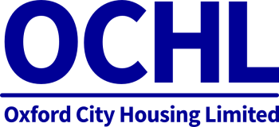
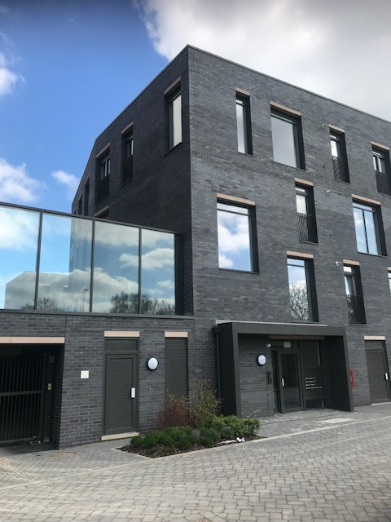
-----------

ANNUAL

REPORT

2018/19

2018/19

OXFORD CITY HOUSING LIMITED

Contents
Delivering new affordable housing for Oxford’s residents

Strategic Report

Overview

Strategy

Performance

Corporate Governance

Financial Statements

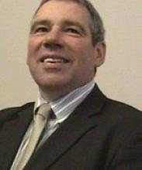

Chairman’s Letter
“During a year in which we have witnessed significant changes in Government policy and strategic direction for the social housing new build agenda within the public sector, OCHL has continued to demonstrate its increasing role to Oxford City Council and its residents in both delivering what our community needs and contributing to the long term financial position of our shareholder.”

Dear Shareholder
It’s been a challenging and ultimately positive 12 months: Board member changes, a delivery vehicle for the Oxfordshire Growth Deal, scoping an OCHL application for significant Government policy changes and finally managing local planning policy compliance issues to progress the current delivery programme. Last but not least, meeting our financial performance obligations to our shareholder and the Council’s Medium Term Financial Plan.

Through all this increased activity we have continued to ensure we review our plans and performance requirements so that we continually meet expectations with growing confidence and pace. Whilst it’s fair to say all these challenges and national government interventions impacted on the immediate planned progress, I’m nonetheless pleased to say OCHL is still very much at the front and centre of influencing, enabling, delivering and forward planning key housing projects and programmes that Oxford City residents desperately need and this is a role we cherish, respect and strive to grow and to build upon.

Strengthening Organisational Capability and Development
As we draw a line under 2018-19 we embark into the new financial year with OCHL’s place as a critical delivery vehicle for new housing in Oxford and beyond. Firmly established with the act of making our first executive appointment, namely Richard Connolly as Interim Managing Director, together with £9.5m of development contracts being signed off just before the end of the financial year and a continued confirmation of delivering financial returns for our shareholder.

Clear Purpose
Finally, I think it is important for OCHL’s success that we have a clear purpose – one that is strongly linked to the city’s needs. Our clear purpose is to deliver housing in Oxford to ultimately improve people’s lives. Our city more than ever before needs significant numbers of new affordable housing for the growth of the region to meet expectations over the next 5 to 10 years and beyond. To help meet these challenges we have to be financially strong and make sure we continue to be an attractive investment and deliver on our performance obligations. I look forward to working with Richard and the existing team as we advance the housing provision in the city, delivering through our strategy and emerging further growth plans, guided by our values and inspired by our purpose. I also look forward to hearing from our shareholder, understanding and delivering on your aspirations and continuing to reward your trust and confidence in OCHL.

Stephen Clarke
Chairman
April 2019

A Volatile Year

Government Policy
Whilst it’s fair to say the Government may have had to prioritise its activities over the past 12 months, this has not prevented significant swings in previous Government held thinking with regards to the social housing agenda. One has to say most have been in the positive namely, eventual removal of the Housing Revenue Account (HRA) debt cap from firstly encouraging additional borrowing bids, additional SHG nationally for new initiatives, the Oxfordshire Growth Deal finally being signed off with resources for new additional social housing dwellings being released, consultation of greater flexibilities in the use of capital receipts (although outcome of revised proposals not as yet published) and certainty with rents, at least for the next 5 years at CPI + 1%.

That said not all was good news for instance the proposed move for local authority rents to be governed by the Social Housing Regulator (SHR). This has removed indefinitely the possibility of local authorities raising social rents to acceptable and Government approved higher levels, even for those on HB or UC. For Oxford City Council this has limited their HRA’s long term future financial strength that in turn could have financed additional borrowing for properties provided by OCHL.

Local Housing Review
Such were the changes happening nationally that it was only fair Oxford City Council reviewed its requirement generally for local housing companies per se. As such the Council commissioned an external assessment of its housing agenda that extended to reviewing planning performance, local land availability, partnership working and the regional economy and growth expectations. I’m pleased to say the conclusions identified a critical and continuing role for OCHL in meeting the expectations of the Council and its wider partnerships both now and for many years to come.

A new strategy, progressing a more dynamic BP and significant on-site progress continues, as well as aspirations to strengthen and widen the experience, knowledge and capabilities of the company’s Board and Executive.

Our Strategy

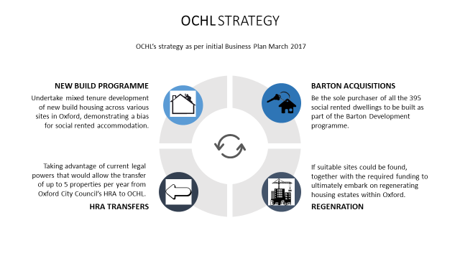

Strategic Review
The regeneration aspirations had been put on hold until suitable sites and schemes were identified and this continues to be the case. Barton acquisitions began towards the end of the 2018-19 financial year and the HRA transfer initiative has seen 10 units move across to OCHL during the first 3 years.

The new borrowing powers afforded to Council’s under the reviews by Government over the past 12 months has resulted in the prospect of further transfers from the Council diminishing in future years, although potentially not completely as opportunities will still exist but confirmed on a scheme by scheme basis.

Going forward, by far the biggest change has been the movement away from managing the sub-market rented accommodation from the series of development schemes planned over the forthcoming years. Previously the company had planned to manage and maintain long term all the social rented, shared ownership and affordable rented properties from its development programme along with those acquired from Barton and the Council’s HRA. However, only those already transferred as at the end of 2018-19 from the Council and the 354 Barton acquisitions will be managed by OCHL. All other properties will be sold either via private sales or to the Council’s HRA, that is to say all social rented, affordable rented and shared ownership dwellings built by the company will now be bought by the Council’s HRA for them to be able to secure government grant, assist in the Oxfordshire Growth Deal, be managed as part of their normal housing stock and let at sub-market rents. The removal of the HRA debt cap allows this to now take place.

Thus, OCHL will continue to have a large amount of activity being undertaken in our Development company subsidiary with only previously transferred HRA and all current and future Barton dwellings to be managed within our Investment company subsidiary.
The above changes in strategic outlook are now reflected in all subsequent scheme performance reports and in the long term BP projections. In the following table, all properties are shown as Open sale (OS) to reflect the strategic direction from the company’s perspective. These homes are either (i) market housing to be sold on the open market or to the Council (as additionality) and (ii) the Section 106 Affordable housing to be sold to the Council.

Property Mix
Activity | Original (Feb 2017) BP Property Mix |  |  |  |  | Revised (Feb 2019) BP Property Mix |  |  |  |  | Movement in BP Property Mix
 | SR | AR | SO | OS | Total | SR | AR | SO | OS | Total | SR | AR | SO | OS | Total
Barton
Phase 1 | 95 | - | - | - | 95 | 95 | - | - | - | 95 | - | - | - | - | -
Phase 2 | 259 | - | - | - | 259 | 259 | - | - | - | 259 | - | - | - | - | -
Sub-Total | 354 | - | - | - | 354 | 354 | - | - | - | 354 | - | - | - | - | -
Development
Cumberlege | 5 | 6 | - | - | 11 | Cumberlege merged with Elsefield
Elsefield | 7 | 4 | - | 6 | 17 | - | - | - | 35 | 35 | (12) | (10) | - | 29 | 7
Harts Close | - | - | 2 | - | 2 | - | - | - | 2 | 2 | - | - | (2) | 2 | -
Rose Hill | 16 | 17 | 9 | - | 42 | - | - | - | 43 | 43 | (16) | (17) | (9) | 43 | 1
Between Towns Road | 16 | 5 | 4 | 15 | 40 | - | - | - | 38 | 38 | (16) | (5) | (4) | 23 | (2)
Underhill Circus | 16 | 4 | - | 21 | 41 | - | - | - | 37 | 37 | (16) | (4) | - | 16 | (4)
Warren Crescent | - | 10 | - | - | 10 | - | - | - | 10 | 10 | - | (10) | - | 10 | -
Lucy Faithful House | n/a | n/a | n/a | n/a | n/a | - | - | - | 36 | 36 | - | - | - | 36 | 36
Edgecombe Drive | n/a | n/a | n/a | n/a | n/a | - | - | - | 7 | 7 | - | - | - | 7 | 7
Bracegirdle, Mortimer, Broad Oak | n/a | n/a | n/a | n/a | n/a | - | - | - | 8 | 8 | - | - | - | 8 | 8
Sub-Total | 60 | 46 | 15 | 42 | 163 | - | - | - | 216 | 216 | (60) | (46) | (15) | 174 | 53
HRA Acquisitions
Combined Schemes | 200 | - | - | - | 200 | 10 | - | - | - | 10 | (190) | - | - | - | (190)
Sub-Total | 200 | - | - | - | 200 | 10 | - | - | - | 10 | (190) | - | - | - | (190)
TOTAL | 614 | 46 | 15 | 42 | 717 | 364 | - | - | 216 | 580 | (250) | (46) | (15) | 174 | (137)
TOTAL (%) | 85.6 | 6.4 | 2.1 | 5.9 | 100 | 62.8 | 0.0 | 40.0 | 37.2 | 100

Measuring Our Progress

Key Performance Indicators (KPI’s)
The adopted KPI’s provide a balanced set of metrics that give emphasis to both financial and non-financial measures. These help the Board and Executive MD assess performance against our strategic priorities and business plans, with non-financial metrics playing a useful role as leading indicators of future performance. OCHL’s Board and management will use these measures to evaluate operating performance and make financial, strategic and operating decisions.

Ethical and Social Responsibility Policy
OCHL is committed to adopting and aligning our activities in line with Oxford City Council’s key priority objective of a cleaner and greener Oxford.

Our construction activities will have reference to incorporating where we can and in the realms of affordability, the concept of sustainability at its core and OCHL believes we can certainly contribute to the low carbon commitments OCC have identified with the introduction of solar panels on our new build schemes where the opportunity exists.

Furthermore, OCHL will request that appropriate focus on waste and recycling activities undertaken by our construction partners is evidenced as well as prioritising opportunities in our construction design for our tenants and new build customers to engage fully with the green agenda.

Development and Financial Performance

Financial Modelling
To better understand the process that has been adopted by OCHL to assess the viability and long term profitability of its development activity two financial exercises, using the Abovo financial modelling software, are undertaken.
Firstly, a “Development” model is assessed for each individual scheme using a number of estimated key assumptions relating to:

- Unit Mix
- Rents and Service Charges
- Capital Costs
- Grant Income
- Subsidy
- Key Dates
- Unit Handover and Sales
- Cashflow Timings
- Discount Rates
- Interest Rates
- Inflationary Rates
- Management Costs

From the above analysis three key measurements for each scheme are compared against the agreed company thresholds for each calculation. These are:

Internal Rate of Return (IRR)

Internal rate of return (IRR) is a metric used in capital budgeting to estimate the profitability of potential investments. Internal rate of return is a discount rate that makes the net present value (NPV) of all cash flows from a particular project equal to zero. OCHL have stated that all its development schemes must reach as a minimum an IRR of 4.00%.

Net Present Value (NPV)

Net present value (NPV) is the difference between the present value of cash inflows and the present value of cash outflows over a period of time. NPV is used in capital budgeting and investment planning to analyse the profitability of a projected investment or project. OCHL have initially just set an NPV threshold of being positive i.e. some additional value is created for OCHL as a result of the scheme progressing.

Payback (PYB)

The payback period is the number of years it takes to break even from undertaking the initial expenditure. Future cash flows are reviewed and compared to the initial capital outlay. OCHL have initially indicated a payback threshold of 40 years, although schemes falling just outside this timeframe will not initially be refused.

Dashboard

Armed with the above agreed company development thresholds each individual scheme can now be assessed and outputs provided on a dashboard report.

The Dashboard analysis charts several outcomes for each individual scheme, namely:

Development Dashboard Outcomes
Financial Performance
The second financial undertaking is taking each of the approved development models for all the schemes and extensions programme and inputting them into the Business Plan model to produce a set of combined financial statements over the next 40 years to ascertain the profitability and financial position (strength) of OCHL and to gauge as to whether it is a good going concern and long term investment.

Other matters that are considered in this analysis include:

- Assumptions;
  - Stock - Future Disposals and Other Income
  - Management Costs - especially those that are non-development related e.g. consultancy, SLA’s etc.
  - Repairs and Maintenance
  - Economic - e.g. Funding, Covenant, Taxation etc.
  - Accounting - namely depreciation policy, revaluations, inter-company transactions etc.

- Workings;
  - Stock - Target Rent Letting rates, RTB numbers
  - Rents – Void Rates, Bad Debts, Uplifts, Arrears etc.
  - Management Costs – drivers, factors, fixed, variable etc.
  - Repairs and Maintenance – drivers, revenue, capital, cyclical etc.
  - Economic – loan types, repayments, accelerated debt redemption, interest paid, covenant parameters etc.
  - Accounting – depreciation rates, componentisation, trial balance adjustments etc.

- Outputs;
  - Cashflows
  - Financial Statements
  - Dashboard
  - Covenants
  - Scenario Planning

Stress Testing

Scenario Planning
In order to demonstrate robustness in the development and financial performance modelling, pushing the boundaries of possible scenarios quickly identifies the associated strengths and weaknesses of OCHL’s proposed plans.

The key in managing this is to firstly be able to identify the limiting factors and key elements and then to be able to measure them before finally being able to understand and compare the overall impact against current expectations.

Again the Abovo products procured by OCHL allows much of the stress testing and scenario planning to take place and produced in a format that can be presented to the Board for consideration and feedback.

Where needed, alternative strategies are explored for their viability and impact.

It must be stated that as a young and ambitious company with all our financing emanating from borrowing the company will initially be highly geared. Our original BP indicated the Board’s desire to adopt a strategy of accelerating debt redemption where financially possible and affordable. Thus, all surplus resources are focussed in adopting this principle of paying down existing debt.

The consequences of being a 100% debt funded entity are that, certainly in the early years of our BP, the ability to meet reasonable loan covenant thresholds is difficult. We have as such agreed with the Council (our funder) that they can provide a certain degree of flexibility and latitude.

Managing Risk

Risk Categories

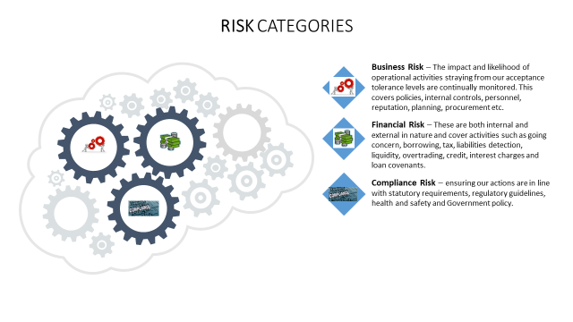
OCHL manages, monitors and reports on the principal risks and uncertainties that can impact our ability to deliver our strategy.

Our present processes and system of internal control that governs how we conduct the business of OCHL may be in its infancy given the limited activity undertaken to date but we feel it is still fit for purpose and will inevitably grow and become more refined and focussed as the OCHL’s activities become greater in number and more complex in nature.

The current risk management system adopted is designed to be a consistent and clear framework for managing and reporting risks from the group’s operations to the Board. The system seeks to avoid incidents and maximize business outcomes by allowing us to:
• Understand the risk environment, identify the specific risks and assess the potential exposure for OCHL.
• Determine how best to deal with these risks to manage overall potential exposure.
• Manage the identified risks in appropriate ways.
• Monitor and seek assurance of the effectiveness of the management of these risks and intervene for improvement where necessary.
• Report on how significant risks are being managed, monitored, assured and the improvements needed are being made.

Risk Process
We aim for a consistent basis of measuring risk to:

• Establish a common understanding of risks on a like-for-like basis, taking into account potential impact and likelihood.
• Report risks to the current Board.
• Inform the ranking of specific risk management activities to the Board to enable key decisions to be risk informed.

Board of Directors

Board Members (2018/19)

In addition there are number of regular Board advisors, namely Alan Wylde (Development), David Watt (Finance) and Catherine Phythian (Secretariat).

Board Activity 2018-19
Name | Appointed | Resigned
Jaqueline Yates | 03 June 2016 | 19 June 2018
Stephen Clarke | 03 June 2016 | -
Jane Winfield | 01 February 2018 | -
Lindsay Cane | 18 January 2017 | -

Group Financial Statements 2018-19

Independent Auditor’s Report

The company’s external auditors, Mazar’s, were formally appointed at the 20th March 2018 Shareholder meeting, on an initial 5 year contract.
They have completed their audit for the 2018/19 financial year and have again provided an unqualified audit opinion.

The following pages, in keeping with the layout as presented previously when reporting new Business Plan updates, attempts to display the consolidated financial position and performance of the OCHL group for 2018/19.

On behalf of the Board we would like to thank Mazar’s for their continued support and work they undertake as our independent auditors and the commentary and guidance they have provided in this role. We value their extensive housing company experience and seek to build on the positive relationship established to date. Their clean bill of health for the 2018/19 year is extremely re-assuring and welcome.

Group Statement of Financial Position

For the year ended 31 March
 | 2018/19 | 2017/18 | Note
Assets | £ | £
Non-Current Assets
Operational Property | 4,900,355 | 1,033,000 | 1
Assets Under Construction | 1,395,719 | 0
Total Non-Current Assets | 6,296,074 | 1,033,000
Current Assets
Trade and Other Receivables | 295,135 | 119,020 | 2
Cash and Cash Equivalents | 379,270 | 11
Total Current Assets | 674,405 | 119,031
Current Liabilities
Trade and Other Payables | (2,589,481) | (702,166) | 3
Total Current Liabilities | (2,589,481) | (702,166)
Net Current Assets | (1,915,076) | (583,135)
Net Assets Less Current Liabilities | 4,380,998 | 449,865
Non-Current Liabilities
Long Term Loans : Amounts Falling Due After More Than One Year | (4,326,670) | (1,053,606) | 4
Total Non-Current Liabilities | (4,326,670) | (1,053,606)
Provisions and Reserves
Share Capital | (100) | (100) | 9
Retained (Earnings)/Losses | (54,228) | 603,841
Total Provisions and Reserves | (54,328) | 603,741
Total Financing and Reserves | (4,380,998) | (449,865)

Group Statement of Profit and Loss and Comprehensive Income

For the year ending 31 March
 | 2018/19 | 2017/18 | Note
 | £ | £
Rent Receivables | 97,488 | 52,796 | 5
Gross Profit | 97,488 | 52,796
Other Income | 0 | 0
Administrative Expenses | (443,120) | (570,565) | 6
Operating Surplus/(Loss) | (345,632) | (517,769)
Interest Payable And Similar Charges | (114,612) | (29,860) | 7
Surplus/(Loss) Before Tax | (460,244) | (547,629)
Corporation Tax | 0 | 0 | 8
Surplus/(Def) After Tax | (460,244) | (547,629)
Unrealised Surplus/(Loss) On Revaluations | 1,118,313 | 0 | 1
Total Comprehensive Income For The Year | 658,069 | (547,629)
Comprehensive Income Brought Forward | (603,741) | (56,112)
Comprehensive Income Carried Forward | 54,328 | (603,741)

Group Statement of Changes in Net Equity

For the year ending 31 March 2019
 | Share Capital | Retained Earnings | Total Equity
 | £ | £ | £
Balance at 01 April 2018 | 100 | (603,841) | (603,741)
Total Comprehensive Profit/(Loss) for the year | 0 | 658,069 | 658,069
Issue of Share Capital | 0 | 0 | 0
Balance at 31 March 2019 | 100 | 54,228 | 54,328

Group Statement of Cash Flows

For the year ending 31 March
 | 2018/19 | 2017/18 | Note
 | £ | £
Operating Activities
Loss Before Tax | (460,244) | (547,629)
Adjustments for:
Depreciation | 7,645 | 0
Interest Payable and Similar Charges | 114,612 | 565
Impairment Loss | 113,158 | 0 | 9
(Increase)/Decrease in Trade Receivables | (176,115) | (106,515)
Increase/(Decrease) in Trade Payables | (251,485) | 633,449
Net Cash From Operating Activities | (652,429) | (20,130)
Investing Activities
Sale/(Purchase) of Operational Property | (2,869,845) | (305,000)
Development Activities | (1,395,719) | 0
Net Cash From Investing Activities | (4,265,564) | (305,000)
Financing Activities
New Long-Term Borrowing | 3,273,064 | 311,000
New Short-Term Borrowing | 2,138,800 | 0
Issue of Share Capital | 0 | 0
Interest Payable and Similar Charges | (114,612) | (565)
Reduction in Borrowing | 0 | 0
Net Cash From Financing Activities | 5,297,252 | 310,435
Net Cashflows | 379,259 | (14,695)

Notes to the Group Financial Statements 2018-19
- Operational Property

 | 2018/19 | 2017/18
 | £ | £
Opening Operational Property 01 April | 1,033,000 | 728,000
Purchase of Operational Property In Year | 2,869,845 | 305,000
Revaluations | 1,118,313 | 0
Impairment | (113,158) | 0
Disposals | 0 | 0
Closing Operational Property 31 March | 4,908,000 | 1,033,000

- Trade and Other Receivables

 | 2018/19 | 2017/18
 | £ | £
Prepayments and Accrued Income | 221,901 | 113,020
Other Receivables | 73,234 | 6,000
Trade and Other Receivables | 295,135 | 119,020

- Trade and Other Payables

 | 2018/19 | 2017/18
 | £ | £
Trade Creditors and Accrued Expenditure | 447,940 | 666,306
Other Payables | 2,141,542 | 35,860
Trade and Other Payables | 2,589,482 | 702,166

- Non-Current Liabilities

 | 2018/19 | 2017/18
 | £ | £
Long Term Loans | 4,326,670 | 1,053,606
Non-Current Liabilities | 4,326,670 | 1,053,606

- Rent Receivables

 | 2018/19 | 2017/18
 | £ | £
Rental Income | 97,488 | 52,796
Rent Receivables | 97,488 | 52,796
- Administration Expenses

 | 2018/19 | 2017/18
 | £ | £
Legal Fees/Services | 101,106 | 14,217
Consultancy Fees | 66,115 | 161,366
Financial Services (SLA) | 125,708 | 92,115
External Audit Fee | 10,000 | 10,000
Tax Advice | 0 | 10,641
Property Repairs | 0 | 3,750
Development Fees | 0 | 278,351
Depreciation | 7,645 | 0
Impairment | 113,158 | 0
Procurement Advice | 6,000 | 0
Insurance | 6,192 | 0
IT (SLA) | 5,666 | 0
Sundry | 1,530 | 125
Administration Expenses | 443,120 | 570,565
- Interest Payable and Similar Charges

 | 2018/19 | 2017/18
 | £ | £
Long Term Borrowing – Capital Value | 56,739 | 1,900
Long Term Borrowing – Cost of Purchase | 0 | 34
Interest and Commission | 57,873 | 27,926
Interest Payable and Similar Charges | 114,612 | 29,860

- Corporation Tax

No corporation tax or deferred tax liability has been posted to the financial statements during this period due to losses incurred. The company has not provided for the deferred tax asset, estimated to be £87,446 (2018 £101,074), as the company does not yet have an established record of profitability.

- Called Up Share Capital

 | 2018/19  Number | 2018/19
 |  | £
Ordinary Shares @ £1 each - Authorised | 100 | 100
Ordinary Shares @ £1 each – Issues and Fully Paid | 100 | 100

- Related Party Transactions

The company is wholly owned by Oxford City Council. The Council has made long term loans totalling £4,326,670 and short terms loans of £2,138,800 to the Group. Interest of £143,327 (2018 £29,860) has been charged on the loans. At the Statement of Financial Position date the amounts due to the Council were:

 | 2018/19 | 2017/18
 | £ | £
Long Term Loans | 4,326,670 | 1,053,606
Short Term Loans | 2,138,800 | 0
Interest | 143,327 | 29,860
Amounts owed to the Council | 131,098 | 494,448
Rental Income owed by the Council | (221,901) | (53,953)
Related Party Transactions | 6,517,994 | 1,523,961
- Audit Fee

 | 2018/19 | 2017/18
 | £ | £
Audit Fee – Audit of Accounts | 10,000 | 10,000
Audit Fee | 10,000 | 10,000
- Financial Instruments

The main risks arising from the Group’s financial instruments are interest rate risk, liquidity risk and credit risk. The directors regularly review and agree policies for managing each of these risks which are summarised below.

Interest rate risk
The Group’s exposure to the risk of changes in market interest rates is limited because its debt obligations are at fixed rates of interest, established at a time when prevailing rates are low. All such borrowings are denominated in Sterling.
The rates of interest are 3.86% and 3.76%.The amount outstanding is shown in note 18 to the financial statements. There is no difference between the values shown above and the fair values of the arrangements.

Credit risk
Credit risk is managed on a company basis. Credit risk arises principally from cash and cash equivalents and deposits with banks and financial institutions as well as credit exposure to customers including committed transactions and outstanding receivables. The Group reviews its banking arrangements carefully to minimise such risks and has put in place credit control procedures to mitigate against risks arising from customers.

Liquidity risk
Management monitors monthly forecasts of the Group’s expected cash flows to ensure that a sufficiently liquid position is maintained. The rental income stream and cost base is predictable and the Group has sought support from its parent undertaking during the initial set up period.

- Capital Risk Management

The Group’s objectives when managing capital are to safeguard the Group’s ability to continue as a going concern in order to achieve the Group’s objectives.
In order to maintain or adjust the capital structure, the Group may adjust the amount of dividends paid to shareholders, return capital to shareholders or issue new shares to reduce debt.

